**Industrial Internship Report on**

**”PASSWORD GENERATOR”**

**Prepared by**

**RACHANA REDDY**

|  |
| --- |
| *Executive Summary* |
| This report provides details of the Industrial Internship provided by upskill Campus and The IoT Academy in collaboration with Industrial Partner UniConverge Technologies Pvt Ltd (UCT).  This internship was focused on a project/problem statement provided by UCT. We had to finish the project including the report in 6 weeks’ time.  My project was “Password Generator using python”  This internship gave me a very good opportunity to get exposure to Industrial problems and design/implement solution for that. It was an overall great experience to have this internship. |

**TABLE OF CONTENTS**

1 Preface 3

2 Introduction 4

2.1 About UniConverge Technologies Pvt Ltd 4

2.2 About upskill Campus 8

2.3 Objective 9

2.4 Reference 9

2.5 Glossary 10

3 Problem Statement 11

4 Existing and Proposed solution 12

5 Proposed Design/ Model 13

5.1 High Level Diagram (if applicable) 13

5.2 Low Level Diagram (if applicable) 13

5.3 Interfaces (if applicable) 13

6 Performance Test 14

6.1 Test Plan/ Test Cases 14

6.2 Test Procedure 14

6.3 Performance Outcome 14

7 My learnings 15

8 Future work scope 16

# 1.Preface

**Password Generator**

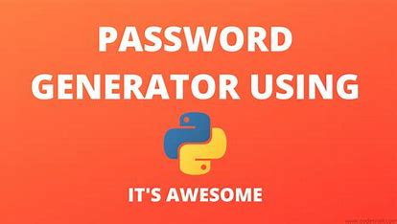

# Summary of 6 weeks Report

***Introduction***:

**The Password Generator project aims to create a secure and customizable tool using Python to generate strong passwords for various applications. The password generator uses Python's built-in random module to ensure randomness and complexity in the generated passwords. This report covers the progress and results achieved over six weeks of development.**

**Week** 1-2: **Project** **Planning** **and** **Research**

During the initial phase, I conducted thorough research on password security, best practices, and existing password generation techniques. The requirements and specifications for the password generator were defined, and the team established the scope and goals for the project.

Week 3: **Basic Password Generation**

I have started implementing the basic password generation logic using Python's random module. A simple function was created to generate random passwords with a fixed length, containing a mix of uppercase letters, lowercase letters, digits, and special characters. The generated passwords were initially tested for randomness and uniqueness.

Week 4: **User** **Customization**

In the fourth week, I added user customization options to the password generator. Users can now specify the desired length of the password and whether to include uppercase letters, lowercase letters, digits, and special characters. I also introduced a secure random number generator for better password strength.

Week 5: **Error** **Handling** **and** **Validation**

The focus of this week was to implement error handling and input validation to ensure that the password generator responds gracefully to incorrect user input. I also conducted extensive testing to identify and fix any potential bugs or edge cases.

Week 6: **Graphical** **User** **Interface** (GUI)

In the final week, I worked on developing a simple Graphical User Interface (GUI) using a Python GUI library, such as Tkinter or PyQt. The GUI allows users to interact with the password generator more intuitively. Users can input their preferences and receive a generated password with the click of a button.

**Conclusion:**

The six-week journey of developing the Password Generator project has been successful. The team has created a robust and user-friendly tool that enables users to generate strong and secure passwords tailored to their preferences. The password generator's integration of error handling and input validation ensures a smooth user experience, reducing the likelihood of encountering unexpected issues.

# About need of relevant Internship in career development :

**Relevant internships are crucial for career development as they provide practical experience and exposure to real-world work environments. They allow individuals to apply their knowledge and skills in a professional setting, bridging the gap between academia and industry requirements. Internships offer the opportunity to explore and understand a chosen field or industry in greater depth, learning from established professionals and gaining insights into industry practices and trends.**

# Brief about My project/problem statement:

The problem statement is to design and implement a “password generator” tool using the Python programming language. The goal of the password generator is to provide users with strong and secure passwords that can be used for various applications, such as online accounts, Wi-Fi networks, or any other system requiring password authentication.

**Opportunity given by USC/UCT:**

The Upskill campus and Uniconverge Technologies gave me a great opportunity to show case my special talents . I would like to thank them for providing such a great internship.

How Program was planned



Thanks to all , who have helped you directly or indirectly.

I would like to suggest you guys to focus on your career rather than other activities.

# Introduction

## About UniConverge Technologies Pvt Ltd

A company established in 2013 and working in Digital Transformation domain and providing Industrial solutions with prime focus on sustainability and RoI.

For developing its products and solutions it is leveraging various**Cutting Edge Technologies e.g. Internet of Things (IoT), Cyber Security, Cloud computing (AWS, Azure), Machine Learning, Communication Technologies (4G/5G/LoRaWAN), Java Full Stack, Python, Front end**etc.



# UCT IoT Platform **(****)**

**UCT Insight** is an IOT platform designed for quick deployment of IOT applications on the same time providing valuable “insight” for your process/business. It has been built in Java for backend and ReactJS for Front end. It has support for MySQL and various NoSql Databases.

* It enables device connectivity via industry standard IoT protocols - MQTT, CoAP, HTTP, Modbus TCP, OPC UA
* It supports both cloud and on-premises deployments.

It has features to  
• Build Your own dashboard  
• Analytics and Reporting  
• Alert and Notification  
• Integration with third party application(Power BI, SAP, ERP)  
• Rule Engine

 

# Smart Factory Platform ()

Factory watch is a platform for smart factory needs.

It provides Users/ Factory

* with a scalable solution for their Production and asset monitoring
* OEE and predictive maintenance solution scaling up to digital twin for your assets.
* to unleased the true potential of the data that their machines are generating and helps to identify the KPIs and also improve them.
* A modular architecture that allows users to choose the service that they what to start and then can scale to more complex solutions as per their demands.

Its unique SaaS model helps users to save time, cost and money.

 

# What is LoRaWAN? - Yeastar Workplace Help based Solution

UCT is one of the early adopters of LoRAWAN teschnology and providing solution in Agritech, Smart cities, Industrial Monitoring, Smart Street Light, Smart Water/ Gas/ Electricity metering solutions etc.

# Predictive Maintenance

UCT is providing Industrial Machine health monitoring and Predictive maintenance solution leveraging Embedded system, Industrial IoT and Machine Learning Technologies by finding Remaining useful life time of various Machines used in production process.



## About upskill Campus (USC)

upskill Campus along with The IoT Academy and in association with Uniconverge technologies has facilitated the smooth execution of the complete internship process.

USC is a career development platform that delivers **personalized executive coaching** in a more affordable, scalable and measurable way.



Seeing need of upskilling in self paced manner along-with additional support services e.g. Internship, projects, interaction with Industry experts, Career growth Services

<https://www.upskillcampus.com/>

upSkill Campus aiming to upskill 1 million learners in next 5 year



## The IoT Academy

The IoT academy is EdTech Division of UCT that is running long executive certification programs in collaboration with EICT Academy, IITK, IITR and IITG in multiple domains.

## Objectives of this Internship program

The objective for this internship program was to

 ☛ get practical experience of working in the industry.

 ☛ to solve real world problems.

 ☛ to have improved job prospects.

 ☛ to have Improved understanding of our field and its applications.

 ☛ to have Personal growth like better communication and problem solving.

## Reference

[1]Python official Documentation (https://docs.python.org.comx )

[2] random Module Documentation

[3] Stack overflow (https://stackoverflow.com)

## Glossary

|  |  |
| --- | --- |
| Terms | Acronym |
| Password  Generator | PGP |
| User Interface | CLI |
| Randomness | API |
| Character set | CS |
| Conditional statements | IDE |

# Problem Statement

**The problem statement for the Password Generator Project is to design and implement a Python-based tool that generates strong and secure passwords for users. The goal is to create a user-friendly application that provides highly random and customizable passwords, ensuring better security for various applications, accounts, or systems that require password authentication.**

1. **Password Complexity**: The password generator should be capable of producing passwords with a mix of uppercase letters, lowercase letters, digits, and special characters to enhance password complexity.

2. **Customizable Length**: Users should have the option to specify the desired length of the generated password. The tool should allow passwords of varying lengths to suit different requirements.

3. Randomness and Uniqueness: The password generator must ensure that the generated passwords are truly random and unique to minimize the risk of unauthorized access.

4. Secure Generation: The application should use a cryptographically secure random number generator to generate passwords. This ensures that the passwords are not easily guessable or predictable.

5. User Interface (Optional): Consider implementing a graphical user interface (GUI) to make the password generator more user-friendly. The GUI should provide an intuitive way for users to interact with the tool and customize their passwords.

6. Error Handling and Validation: The password generator should handle incorrect user input gracefully and provide appropriate error messages to ensure a smooth user experience.

7. Strength Indicator (Optional): An optional feature could be included to visually indicate the strength of the generated password based on commonly accepted password strength criteria.

8. Password Policy Enforcement (Optional): The application may allow users to enforce specific password policies, such as a minimum number of characters of each type (uppercase, lowercase, digits, etc.).

9. Secure Password Storage (Optional): If applicable, consider implementing a secure method for users to store generated passwords for future reference, following proper encryption protocols.

Deliverables:

The final deliverable will be a functional password generator application written in Python. The application should adhere to the specified requirements and provide users with secure, random, and customizable passwords. If a GUI is implemented, it should be user-friendly and intuitive.

**Success Criteria:**

The success of the Password Generator Project will be measured based on the following criteria:

1. Password Strength: The generated passwords must meet standard security guidelines and demonstrate high entropy (randomness).

2. Customization: Users should be able to customize the length and character types of the generated passwords.

3. Randomness and Uniqueness: The passwords generated by the tool should exhibit a high degree of randomness and must not repeat.

4. User Interface (if applicable): If a GUI is developed, it should provide an intuitive and seamless user experience.

5. Error Handling: The application should handle incorrect user input gracefully and provide meaningful error messages.

Overall, the successful completion of the Password Generator Project will provide users with a reliable tool to create strong and secure passwords, enhancing their digital security and privacy across various online platforms and systems.

# Existing and Proposed solution

Existing solution :

There are several existing solutions for password generator projects using Python available on the internet. These solutions ranged from simple command-line scripts to more complex applications with graphical user interfaces. However, please note that the landscape of open-source projects is continuously evolving, and new solutions may have emerged since then.

To find existing solutions for a password generator project using Python, you can explore the following sources:

1. GitHub: GitHub is a popular platform for hosting open-source projects. You can search for "Python password generator" or similar keywords on GitHub to find relevant projects. Look for projects with high stars, recent updates, and well-documented code.

2. Python Package Index (PyPI): PyPI is the official Python package repository. You can search for password generator packages written in Python. Some packages may provide password generation as a module that you can incorporate into your project.

3. Online Tutorials and Blog Posts: Many developers share their password generator implementations through tutorials or blog posts. You can find step-by-step guides and code examples to understand how others have created password generators using Python.

4. Open-Source Password Managers: Some open-source password manager projects may include a password generator as part of their functionality. Even if you are not looking for a password manager, you can explore their codebase to learn about password generation techniques.

Remember to review the licenses of any open-source projects you come across and ensure they align with your intended use. Additionally, when using code from existing projects, it's essential to attribute the original authors and follow any licensing requirements.

As a specific example, one popular Python library for password generation is "Passlib." It provides various password hashing and generation schemes and is well-maintained. However, keep in mind that there might be many other solutions out there, and it's always best to research and choose the one that best fits your project's requirements.

## Proposed Solution:

The Password Generator project aims to create a secure and customizable tool to generate strong passwords for various applications. The solution will be implemented in Python, utilizing the built-in `random` and `string` modules to ensure randomness and flexibility in generating passwords.

**Key Features :**

1. Password Complexity: The proposed solution will allow users to create passwords with a mix of character types, including uppercase letters, lowercase letters, digits, and special characters. This will ensure strong password complexity, making it difficult for potential attackers to guess or crack the passwords.

2. User Customization: Users will have the option to customize the password length and choose which character types to include in their generated passwords. This customization will enable users to tailor passwords according to specific requirements of different applications or systems.

3. Cryptographically Secure Randomness: The solution will use Python's `secrets` module, which provides a cryptographically secure random number generator, ensuring the generated passwords are highly unpredictable and resistant to attacks.

4. Error Handling and Validation: The solution will incorporate error handling and input validation to guide users in providing correct and appropriate inputs for password generation. Users will receive helpful error messages if they provide invalid input.

5. Graphical User Interface (Optional): Depending on the project scope, the solution may include a simple Graphical User Interface (GUI) using a Python GUI library like Tkinter or PyQt. The GUI will offer users an intuitive and user-friendly way to interact with the password generator.

6. Password Strength Indicator (Optional): An optional feature may be implemented to visually indicate the strength of the generated passwords based on common password strength criteria, such as length, character diversity, and entropy.

7. Password Storage (Optional): For enhanced usability, an optional feature may be included to allow users to securely store generated passwords for future reference. This feature will follow proper encryption protocols to maintain security.

**Implementation Overview:**

1. Import required modules: The Python `random` and `string` modules will be imported to handle random number generation and string manipulations, respectively.

2. Implement password generation function: A function will be designed to generate passwords based on user-defined preferences. The function will utilize the `random` and `string` modules to create random passwords with the desired length and character types.

3. User input and customization: The program will prompt the user to specify the desired password length and which character types to include. Input validation will be implemented to ensure valid user inputs.

4. Password Strength Indicator (Optional): If chosen to be implemented, the password strength indicator will evaluate the generated password and display its strength using appropriate criteria.

5. Graphical User Interface (Optional): If included, a GUI will be developed to offer users a more interactive and user-friendly experience in generating passwords.

6. Password Storage (Optional): If opted for, the solution will provide a secure way to store generated passwords, ensuring they are encrypted and protected.

Conclusion:

**The proposed solution for the Password Generator project in Python aims to provide a flexible, secure, and user-friendly tool for generating strong passwords. By implementing key features like password complexity, user customization, and cryptographically secure randomness, the solution will help users enhance their digital security and privacy. The optional features of a GUI, password strength indicator, and password storage further improve the usability and convenience of the password generator.**

## Code submission (Github link)

* 1. Report submission (Github link) :
  2. Code submission link :

Source code for Password Generator:

import random

import string

def generate_password(length=12, include_digits=True, include_special_chars=True):

characters = string.ascii_letters

if include_digits:

characters += string.digits

if include_special_chars:

characters += string.punctuation

password = ''.join(random.choice(characters) for _ in range(length))

return password

def main():

print("Welcome to the Password Generator!")

length = int(input("Enter the desired length of the password: "))

include_digits = input("Include digits (yes/no)? ").lower() == "yes"

include_special_chars = input("Include special characters (yes/no)? ").lower() == "yes"

password = generate_password(length, include_digits, include_special_chars)

print("Generated Password:", password)

if _name_ == "_main_":

main()

**PROPOSED MODEL:**

Here is the model :

This model is a high-level outline of the project's structure and key components:

1. User Interface:

- Develop a Graphical User Interface (GUI) using a Python GUI library like Tkinter or PyQt to provide a user-friendly interaction with the password generator.

- Include input fields for password length and checkboxes to allow users to choose whether to include uppercase letters, lowercase letters, digits, and special characters.

2. Password Generation Function:

- Implement a function responsible for generating random passwords based on the user's preferences.

- Utilize the Python `random` module or `secrets` module for secure and random password generation.

- Combine characters from the selected character set (uppercase, lowercase, digits, special characters) to create the final password.

- Ensure that the generated passwords are unique and have sufficient complexity for security.

3. Error Handling and Validation:

- Implemented error handling to deal with incorrect user inputs, such as non-numeric password length or no character type selected.

- Validate user inputs to prevent invalid or out-of-range values.

4. Character Sets and Password Complexity:

- Define constants for different character sets (uppercase, lowercase, digits, special characters) that the user can choose from.

- Calculate the password's complexity, such as entropy, to give users an idea of the password strength.

5. **Optional** **Features**:

- Implement additional optional features like a password strength indicator to visually represent the password's strength based on complexity criteria.

- Provide an option to save the generated passwords securely, potentially using encryption, if required.

6. **Integration** **and** **Output**:

- Integrate the password generator function with the GUI so that the generated passwords are displayed to the user.

- Offer the option to copy the generated password to the clipboard for easy use in other applications.

7. **Documentation**:

- Created comprehensive documentation explaining the purpose, functionality, and usage of the password generator project.

- Included instructions for running the application and customizing the code if needed.

8. **Testing**:

- Conduct thorough testing to ensure the functionality and correctness of the password generator.

- Test different scenarios, including various password lengths and character set combinations.

Remember that this is a high-level proposed model, and the actual implementation may vary based on your specific project requirements and preferences. For a more detailed and accurate model, you can start building your project step by step, following best practices for Python development and security considerations for password generation.

**HIGH LEVEL DIAGRAM :**

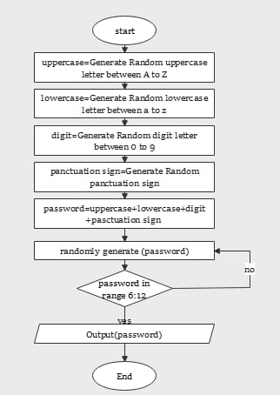

Figure 1: HIGH LEVEL DIAGRAM OF THE SYSTEM

* 1. **Low** **Level** **Diagram**:

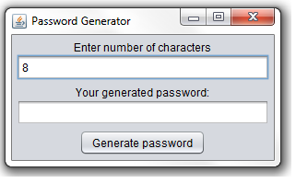

## Interfaces (if applicable)

# Block Diagram:

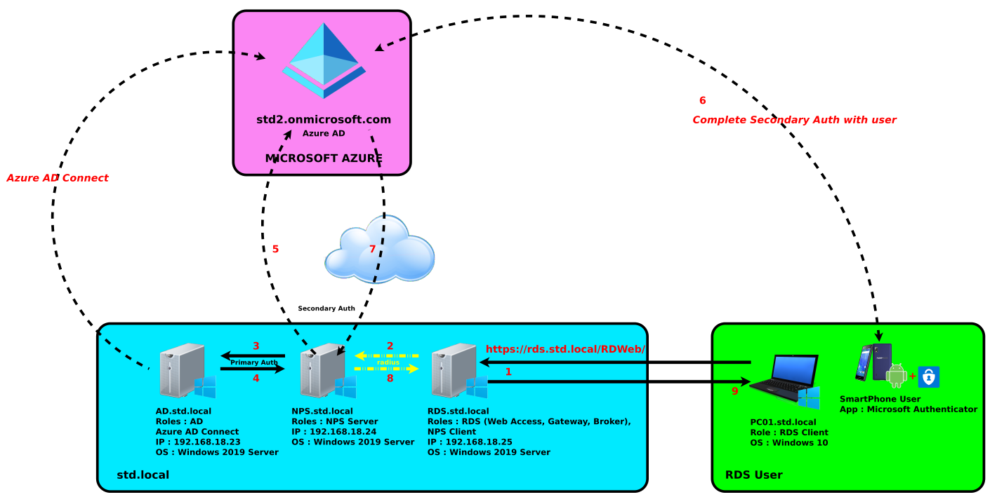

# Flow Chart :

# 

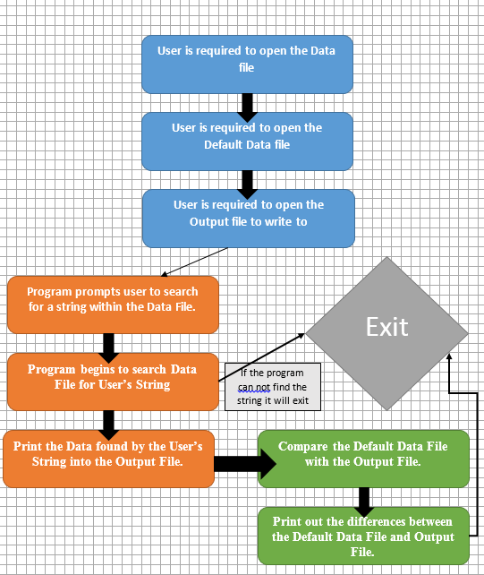

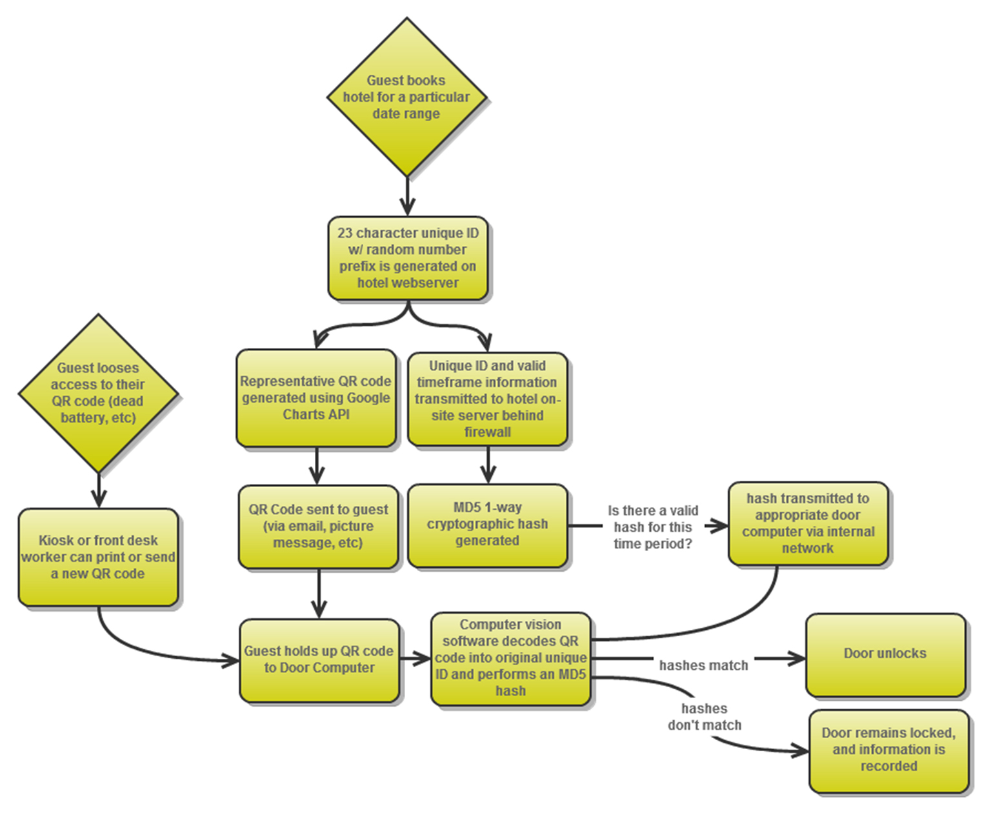

# Memory Buffer Management System:

In the context of a password generator project using Python, a memory buffer management system refers to a mechanism or approach to handle sensitive data like passwords securely within the program's memory. Since passwords are sensitive information, it's essential to manage their storage and handling carefully to minimize the risk of exposing them to potential security threats.

One common approach to memory buffer management in Python is to use the `secrets` module, which provides functions for generating cryptographically secure random numbers and managing sensitive data, such as passwords, in memory. The `secrets` module is designed specifically for secure generation and management of secrets, making it suitable for password generation.

Here's an example of how the `secrets` module can be used in a password generator project:

python

import secrets

import string

def generate_password(length=12, include_digits=True, include_special_chars=True):

characters = string.ascii_letters

if include_digits:

characters += string.digits

if include_special_chars:

characters += string.punctuation

password = ''.join(secrets.choice(characters) for _ in range(length))

return password

# Example usage

password = generate_password(length=16, include_digits=True, include_special_chars=True)

print(password)

In this example, the `secrets.choice()` function is used instead of `random.choice()` from the standard `random` module. The `secrets.choice()` function provides a more secure way to choose random elements from the character set.

Using the `secrets` module helps mitigate potential security risks associated with random number generation, especially for sensitive data like passwords. The module relies on the underlying operating system's cryptographically secure random number generator, which makes it suitable for generating strong and unpredictable passwords.

Remember that in a real-world application, managing passwords securely goes beyond just memory buffer management. It's crucial to consider other security aspects, such as secure storage, encryption, and following best practices for handling user credentials and sensitive data.

# Performance Test

Performance testing in a password generator project involves evaluating the speed and efficiency of the password generation algorithm under different conditions and workloads. The primary objective of performance testing is to ensure that the password generator can generate strong passwords quickly and efficiently, even when handling a large number of requests. Here are some key aspects to consider when conducting performance testing for a password generator project in Python:

1. **Load** **Testing**:

- Test the password generator with a range of user loads, from low to high, to determine how it performs under different levels of demand.

- Measure the response time and resource utilization (CPU, memory) for each load level.

2. **Stress** **Testing**:

- Subject the password generator to extreme load levels to identify its breaking point or performance degradation threshold.

- Monitor the system's behavior during stress testing and observe how it recovers after the stress is removed.

3. **Randomness** **and** **Uniqueness**:

- Evaluate the randomness and uniqueness of the generated passwords to ensure they meet security requirements.

- Verify that the passwords are not biased towards specific characters or patterns.

4. **Execution** **Time**:

- Measure the time it takes to generate passwords of various lengths and complexity levels.

- Check for any performance bottlenecks that may slow down password generation.

5. **Customization** **Options**:

- Test the password generator with different customizations, such as length, character types, and the inclusion/exclusion of special characters.

- Verify that the generator can handle various configurations efficiently.

6. **Cryptographic** **Security**:

- Assess the cryptographic strength of the random number generator used in the password generation process.

- Ensure that a cryptographically secure random number generator is employed for generating passwords.

7. **Error** **Handling**:

- Test the password generator's behavior when encountering incorrect or invalid user input.

- Verify that it provides appropriate error messages and gracefully handles unexpected scenarios.

8. **GUI** (**if** **applicable**):

- If the project includes a graphical user interface (GUI), evaluate the GUI's responsiveness and performance during password generation.

9. **Long**-**Term** **Performance**:

- Run the performance tests over an extended period to observe any degradation or resource leaks.

Tools like `timeit` or Python's built-in `time` module can be used to measure the execution time of specific functions or sections of code. Additionally, external testing frameworks like `pytest` can be utilized to create automated performance tests with custom load profiles.

By conducting comprehensive performance testing, you can ensure that the password generator project performs optimally and delivers secure, strong passwords efficiently, even under high demand.

# Constraints :

In a password generator project using Python, constraints are rules or limitations imposed on the generated passwords to ensure they meet certain security standards and comply with specific requirements. These constraints help create strong and secure passwords that are less susceptible to being compromised. Here are some common constraints used in a password generator project:

1. **Password** **Length**: Define a minimum and maximum length for the generated passwords. Longer passwords generally offer better security.

2. **Character** **Types**: Allow users to specify the inclusion or exclusion of different character types in passwords. Common character types include uppercase letters, lowercase letters, digits, and special characters (e.g., symbols and punctuation).

3. **Complexity** **Requirements**: Require a minimum number of characters from each character type to ensure that the password contains a mix of different characters, making it harder to guess.

4. **Avoid** **Ambiguous** **Characters**: Exclude similar-looking characters (e.g., 'l' and '1', 'O' and '0') that can cause confusion, making passwords easier to remember.

5. **Avoid** **Common** **Words** **and** **Patterns**: Prevent the generation of passwords based on dictionary words, common phrases, or predictable patterns to enhance unpredictability.

6. **No** **Personal** **Information**: Avoid including any personal information (e.g., name, birthdate) in the generated passwords to reduce the risk of password guessing based on publicly available information.

7. **Avoid** **Repeating** **or** **Sequential** **Characters**: Discourage the use of repeating characters (e.g., "1111") or sequential characters (e.g., "1234") to increase password complexity.

8. **Cryptographically** **Secure** **Randomness**: Use a cryptographically secure random number generator to ensure that passwords are truly random and not predictable.

9. **Exclude** **Previously** **Used** **Passwords**: If the password generator is part of a password management system, make sure that generated passwords do not match previously used passwords to avoid password reuse.

10. **Error** **Handling**: Implement appropriate error handling and validation to handle incorrect user inputs gracefully and provide helpful feedback.

11. **Secure** **Storage** (if applicable): If the project involves storing passwords, use proper encryption and security measures to protect the passwords from unauthorized access.

These constraints should be carefully designed and implemented to strike a balance between security and usability. It's essential to allow users enough flexibility to create passwords they can remember while still ensuring the generated passwords meet the desired security standards.

## Test Plan/ Test Cases:

## A test plan for the Password Generator project in Python outlines the various test cases that will be conducted to verify the functionality and reliability of the password generator. It ensures that the generator is capable of producing strong and secure passwords with the required features. Below is a sample test plan for the Password Generator project:

*Test Plan: Password Generator Project*

1. *Password Complexity Test:*

- Test Case 1: Verify that the generated password contains at least one uppercase letter.

- Test Case 2: Verify that the generated password contains at least one lowercase letter.

- Test Case 3: Verify that the generated password contains at least one digit.

- Test Case 4: Verify that the generated password contains at least one special character.

2. *Password Length Test:*

- Test Case 5: Verify that the generated password has the correct length specified by the user.

- Test Case 6: Verify that the minimum and maximum password length limits are enforced.

3. *Randomness and Uniqueness Test:*

- Test Case 7: Generate multiple passwords and check for duplicates to ensure uniqueness.

- Test Case 8: Verify that the generated passwords exhibit a high degree of randomness.

4. *User Customization Test:*

- Test Case 9: Test the password generation with various user-customized settings.

- Test Case 10: Verify that the generated password adheres to the user's specified character type preferences.

5. *Error Handling Test:*

- Test Case 11: Test the generator with invalid input values (e.g., negative password length, invalid character types).

- Test Case 12: Verify that appropriate error messages are displayed for invalid input.

6. *Graphical User Interface (if applicable):*

- Test Case 13: Verify the correct functionality of the GUI components, such as buttons and input fields.

- Test Case 14: Test the password generation process via the GUI and validate the output.

7. *Cryptographically Secure Random Number Generation (if applicable):*

- Test Case 15: Ensure that the passwords generated using a cryptographically secure method are indeed secure and meet industry standards.

8. *Performance Test:*

- Test Case 16: Test the password generator's performance with a large number of password generations to ensure it executes within an acceptable time frame.

9. *Integration Test (if applicable):*

- Test Case 17: Test the integration of the password generator with other applications (e.g., password managers) to verify smooth operation.

10. *User Acceptance Test:*

- Test Case 18: Gather feedback from users to evaluate the usability and satisfaction of the password generator.

11. *Security Review (optional, but highly recommended):*

- Conduct a thorough security review to identify and address potential vulnerabilities in the password generation process.

* 1. Note: The test plan should be comprehensive, covering various scenarios and edge cases to ensure the password generator is robust and reliable. Additionally, it's essential to conduct regular regression testing to maintain the integrity of the generator as the project evolves and new features are added.

# .Test Procedure :

A test procedure in a password generator project using Python is a set of systematic steps and test cases designed to verify the correctness, functionality, and security of the password generator. The goal of testing is to ensure that the password generator works as intended, produces strong and secure passwords, handles various scenarios correctly, and provides a smooth user experience. Here's a basic outline of the test procedure for a password generator project:

1. **Unit** **Tests**:

- Test the basic password generation function to ensure it generates passwords of the specified length.

- Verify that the generated passwords contain the desired character types (uppercase, lowercase, digits, special characters) based on user preferences.

- Check that the password generation function produces unique passwords for different calls.

- Test edge cases, such as generating passwords with minimum and maximum allowed lengths.

2. **Customization** **Tests**:

- Test the password generator's ability to handle different user inputs for password length and character types.

- Verify that invalid inputs (e.g., negative length, incorrect character type selection) are appropriately handled with error messages or default values.

3. **Randomness Tests**:

- Check the randomness of the generated passwords using statistical tests to ensure they exhibit true randomness and are not predictable.

- Verify the use of cryptographically secure random number generation techniques, especially if a secure password is a requirement.

4. **Error Handling Tests**:

- Test the password generator's behavior when encountering unexpected errors, such as system failures or memory issues.

- Verify that proper error messages are displayed to users when input validation fails.

5. **User** **Interface** **Tests** (if applicable):

- Test the graphical user interface (GUI) for user-friendliness and intuitiveness.

- Verify that the GUI correctly captures user preferences and generates passwords accordingly.

6. **Security** **Tests**:

- Ensure the password generator adheres to password security best practices, such as generating long and complex passwords.

- Verify that the passwords generated are not stored or logged anywhere and are only presented to the user.

7. **Integration** **Tests** (if applicable):

- If the password generator integrates with other applications or systems, conduct tests to verify the seamless integration and data exchange.

8. **Stress** **Tests** (optional):

- Test the password generator's performance and stability under heavy usage, generating a large number of passwords in a short period.

9. **Vulnerability** **Tests** (optional):

- Conduct security assessments, including code reviews and penetration testing, to identify potential vulnerabilities and address them promptly.

It's crucial to document the test procedure and its results thoroughly. Test automation can also be considered to streamline the testing process and ensure consistent and repeatable test cases. By rigorously testing the password generator, you can increase confidence in its reliability and security for real-world use.

# My learnings:

1. *Randomness and Security*: Understanding the importance of randomness and security in password generation. Learning how to use Python's `random` and `secrets` modules to ensure the passwords generated are strong, unpredictable, and resistant to brute-force attacks.

2. *String Manipulation*: Gaining proficiency in string manipulation techniques to combine different character types (uppercase letters, lowercase letters, digits, and special characters) to form complex and diverse passwords.

3. *User Input and Validation*: Learning how to handle user input effectively and implementing validation to ensure the input is within acceptable boundaries (e.g., password length, character type selection) to prevent errors and unexpected behavior.

4. *Error Handling*: Understanding the significance of error handling to provide users with clear and informative error messages when incorrect input is provided or unexpected issues occur during password generation.

5. *Customization and Flexibility*: Implementing customization options to allow users to create passwords tailored to their specific requirements, balancing security with usability.

6. **Graphical User Interface (Optional)**: If a GUI is developed, learning how to use Python GUI libraries (e.g., Tkinter, PyQt) to create an interactive and user-friendly interface for the password generator.

7. *Security Best Practices*: Familiarity with password security best practices, such as avoiding common passwords, storing passwords securely, and not using personal information as part of the generated passwords.

8. *Version Control*: Learning to use version control systems like Git to track changes, collaborate with others, and manage the project effectively.

9. *Project Management*: Gaining experience in project planning, defining requirements, setting milestones, and managing time to ensure the project progresses smoothly.

10. *Documentation*: Understanding the importance of documenting the project, including code comments, function explanations, and user instructions, to make it easier for others to understand and use the password generator.

11. *Testing*: Learning how to write and conduct tests to ensure the password generator functions as expected under various scenarios, catching and fixing bugs or vulnerabilities.

12. *Security Implications*: Understanding the potential security implications of password generation and the importance of secure password storage and handling.

Overall, working on a password generator project in Python can provide valuable insights into programming concepts, security considerations, and project management skills, which can be applied to various other software development projects in the future.

# Future work scope

Future Scope in Password Generator Project using Python:

1. **Enhanced** **Password** **Strength**: Implementing a password strength indicator that assesses the generated passwords against common password policies and provides users with feedback on the strength of their chosen passwords. This feature can help users create stronger and more secure passwords.

2. **Secure** **Password** **Storage**: Expanding the project to include secure password storage capabilities. Users can securely store generated passwords within the application, protecting them with encryption and access control mechanisms.

3. **Password** **Policy** **Enforcement**: Adding the option for users to enforce specific password policies based on their needs or the requirements of the systems they are using the passwords for. This could include constraints on length, character types, and expiration.

*4.* ***Password******Management******Integration****: Integrating the password generator with popular password management systems or password managers. This integration would allow users to directly save generated passwords to their preferred password manager for easy organization and retrieval.*

*5.* ***Passphrase******Generation****: Extending the project to support passphrase generation in addition to traditional passwords. Passphrases are longer sequences of words that can be easier to remember while maintaining strong security.*

*6.* ***Biometric******Authentication****: Exploring biometric authentication methods (e.g., fingerprint or facial recognition) as an additional layer of security for accessing the password generator application.*

*7.* ***Multi****-****language******Support****: Providing multi-language support for the password generator's user interface to cater to users from different linguistic backgrounds.*

*8.* ***Randomness******and******Entropy******Improv*ement**: Investigating methods to improve the randomness and entropy of the generated passwords by utilizing more advanced random number generation techniques or external entropy sources.

9. **Web**-**Based** **Application**: Transforming the project into a web-based application, allowing users to access the password generator from any device with an internet connection.

10. **Mobile** **Application**: Developing a mobile application version of the password generator, making it more convenient for users to generate passwords on the go.

11. **Password** **History** **and** **Usage** **Tracking**: Introducing a feature to keep a history of generated passwords and track their usage across various applications or systems.

12. **Two**-**Factor** **Authentication** (**2FA**) **Integration**: Integrating two-factor authentication methods to enhance the security of user accounts associated with the passwords generated by the application.

The future scope of the project will depend on the specific needs and requirements of the users and the evolving landscape of cybersecurity. Prioritizing security, usability, and user feedback will be crucial in shaping the password generator's future developments.